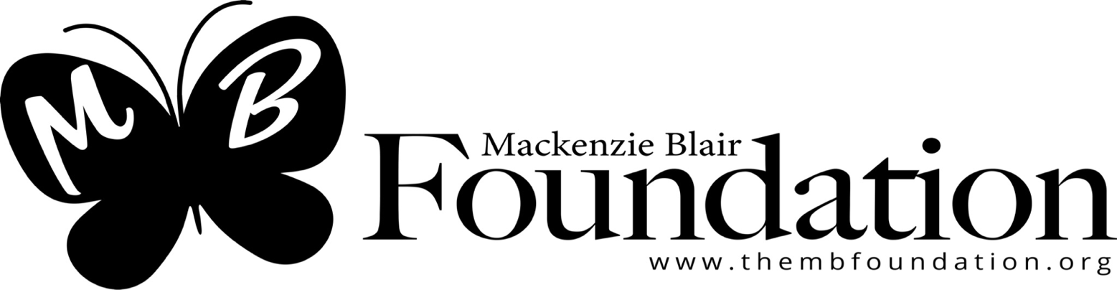
P.O. BOX 545
Jackson, NJ 08527
thembfbingo@gmail.com

To Whom it May Concern:

Did you know that 450 children ages 12 months - 18 years have died from Sudden Unexplained Death in Childhood (SUDC) in the year 2021, which at this time, has no known cause or prevention? It is the fifth leading category of death among children ages 1 to 4 year with research and awareness of SUDC remaining limited. The primary missions of The Mackenzie Blair Foundation (EIN # 82-2547475) are to raise awareness for SUDC, provide scholarships to local high school students, and send care packages to grieving families. The short-term goal for the foundation is to assist families who have lost their child to SUDC with funeral costs.

The Mackenzie Blair Foundation will be hosting a Tricky Tray on April 19, 2024. There will be three levels of prizes for the Tricky Tray with a grand prize. We anticipate the generous support of local businesses like yours to make this a successful event! Most of our prizes will consist of goods and services donated by local businesses.

We are respectfully requesting your support through donations such as gift certificates, merchandise, memorabilia, or services that can be used in our tricky tray. Please consider assisting in our efforts. ln return for your generosity, your donations will be acknowledged in our Tricky Tray pamphlet, making your business visible to people from Middlesex, Monmouth, Ocean and Somerset counties.

Please send your donation directly to the address in the letterhead above, or call 848-248-2897, so we may make arrangements to pick up local donations. If you are interested in a sponsorship, please use the attached form and mail it back to us, or you may complete your sponsorship donation directly on our website: website https://thembfoundation.networkforgood.com. If you have generously donated to us in the past, we appreciate your continued support as our success greatly depends on the support we receive from family, friends and organizations such as yours!

Thank you in advance for your service to The Mackenzie Blair Foundation.

Thank you in advance,
Nicole Hanrahan
Nicole Hanrahan
President & Co-Founder
(848) 248-2897

If you are interested in a sponsorship, please use the form below and mail it back or you may complete your sponsorship donation directly on our website https://thembfoundation.networkforgood.com. Our success greatly depends on the support we receive from family, friends, and organizations such as you. As an official sponsor of the event, your name will be in the brochure given to each attendee that night identifying you as a sponsor. Each sponsorship level highlights different opportunities specializing all financial levels.

Monetary Amount | $50 | $150  Table Sponsor  15 Available | $250  Silver | $500  Gold | $1000  Diamond  5 Available | $5000  Platinum  Event Sponsor  1 Available
Business Card Ad
Ad |  |  | 1/2 Page | Full Page | Full Page | Full Page
Table Sponsorship with promotional material
Sponsor a basket |  |  | Tier 1 Basket | Tier 2 Basket | Tier 3 Basket | Grand Prize Basket
Free Tickets to Event |  |  |  | 2 tickets | 4 Tickets | 1 table
Specialized social media posts
Specialized email before event
Banner over Main Stage

-----------------------------------------------------------------------------------------

Please makes checks payable to The Mackenzie Blair Foundation  Mail this portion of the sponsorship and check to:  The Mackenzie Blair Foundation  P.O.Box 545  Jackson, NJ 08527 | Company Name: _____________________________________________________  Contact Name: ____________________________ ___ Phone Number: _________________  Address: ___________________________ ______State: ___________ Zip: _____________  Email:______________________________________ $ Amt Donated______________  Sponsorship Level: ____________________________________

